Course Content: Data Science with AI
A Data Science with Artificial Intelligence (AI) course teaches you how to collect and analyze data, build machine learning models, use AI tools, and develop intelligent applications. It typically combines programming, statistics, machine learning, deep learning, and Generative AI.
Complete course syllabus

Module 1: Python Programming
- Python fundamentals, variables, data types and operators
- Conditions, loops, functions and modules
- Lists, tuples, dictionaries and sets
- Object-oriented programming
- File handling, exceptions and APIs
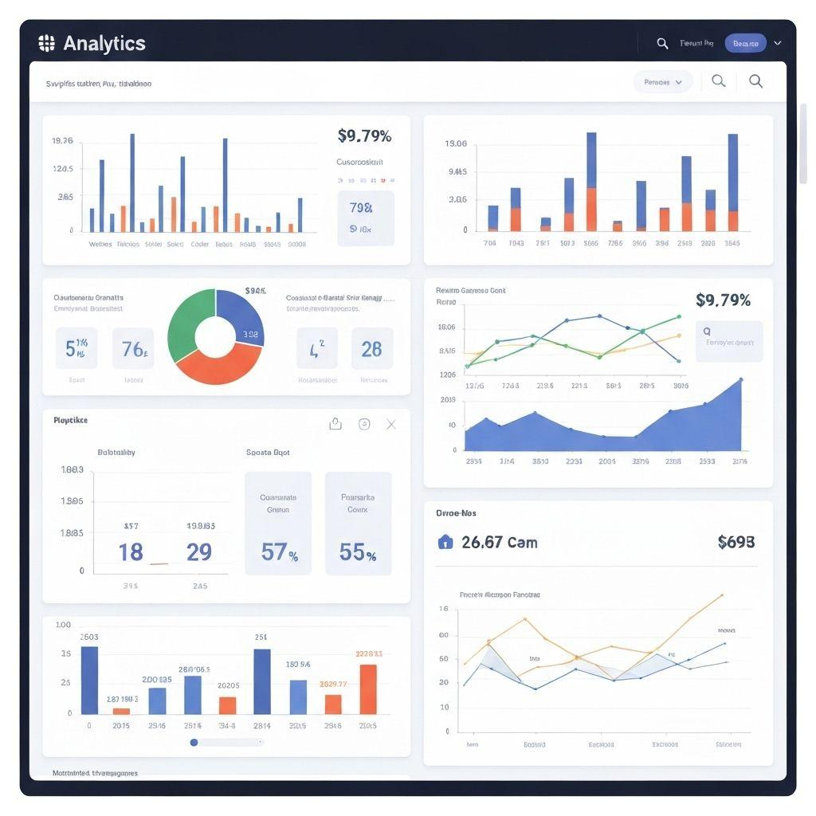
Module 2: Mathematics and Statistics
- Descriptive and inferential statistics
- Probability and probability distributions
- Mean, median, mode, variance and standard deviation
- Hypothesis testing and correlation
- Linear algebra, vectors and matrices
- Basic calculus and optimization
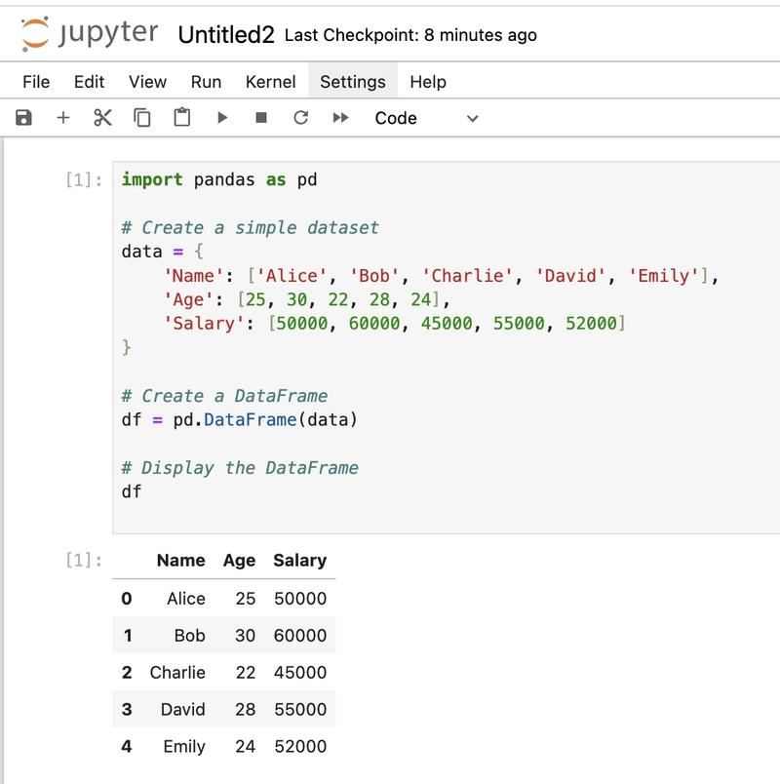
Module 3: Data Analysis and Manipulation
- NumPy and Pandas
- Data cleaning and preprocessing
- Handling missing values and duplicates
- Exploratory Data Analysis (EDA)
- Data transformation and feature engineering
- Data visualization using Matplotlib and Seaborn

Module 4: SQL and Databases
- SQL queries and database fundamentals
- SELECT, WHERE, GROUP BY and ORDER BY
- Joins, subqueries and aggregate functions
- Window functions
- Database design and data extraction
- Introduction to NoSQL databases
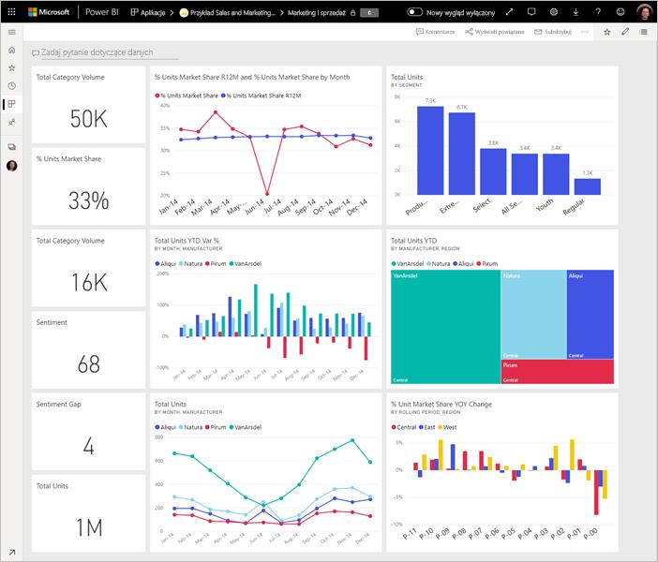
Module 5: Business Intelligence and Visualization
- Power BI or Tableau fundamentals
- Interactive dashboards and reports
- KPIs and business metrics
- Data storytelling and presentation
- DAX basics if using Power BI
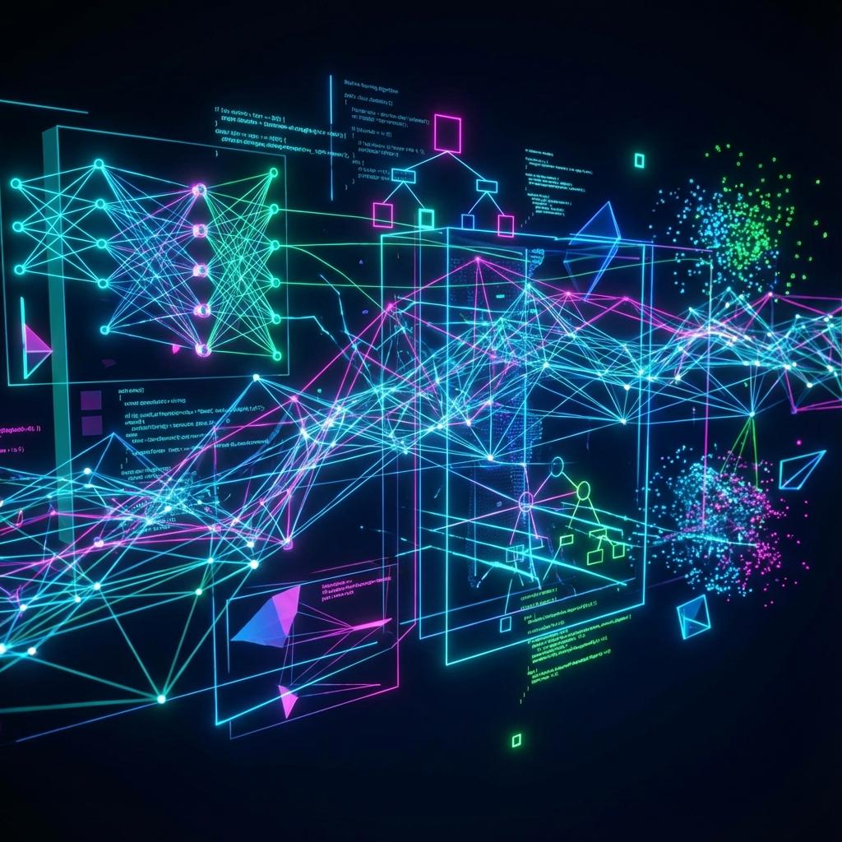
Module 6: Machine Learning
- Supervised and unsupervised learning
- Linear and logistic regression
- Decision trees, random forests and gradient boosting
- K-means clustering and dimensionality reduction
- Train-test split and cross-validation
- Model evaluation and hyperparameter tuning
- Scikit-learn
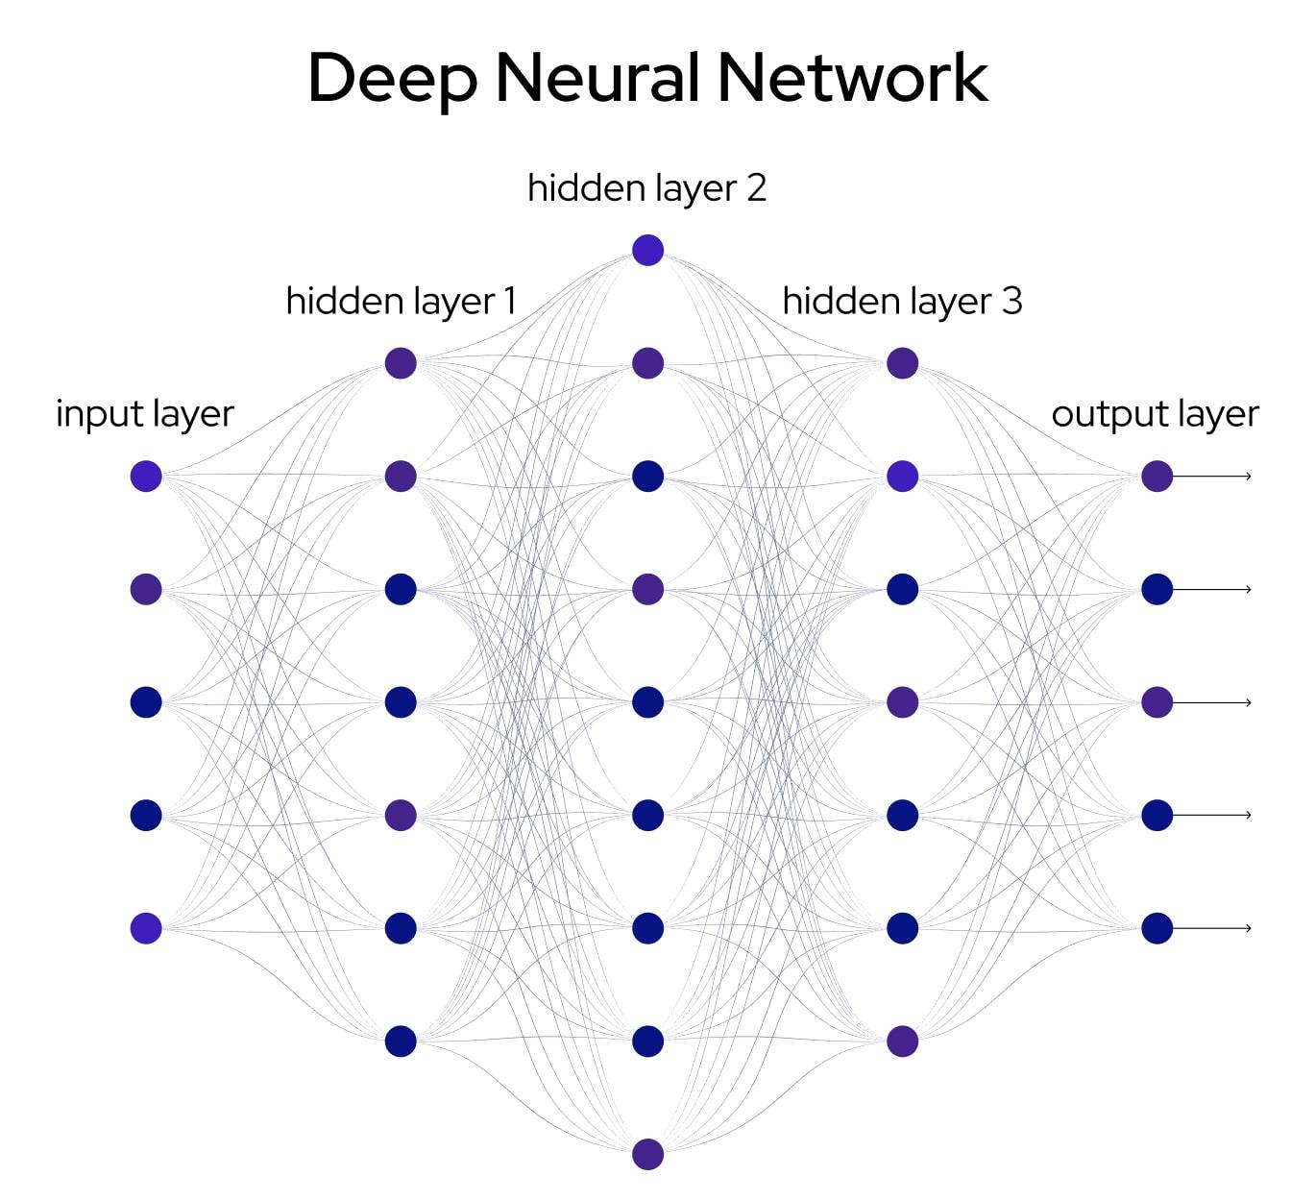
Module 7: Deep Learning
- Artificial neural networks
- TensorFlow or PyTorch
- Forward propagation and backpropagation
- Convolutional Neural Networks (CNNs)
- Recurrent Neural Networks (RNNs) and sequence models
- Model training, loss functions and optimization

Module 8: Generative AI and Large Language Models
- Generative AI fundamentals
- Large Language Models (LLMs)
- Prompt engineering
- Using AI APIs
- Embeddings and vector databases
- Retrieval-Augmented Generation (RAG)
- Building AI chatbots and document assistants
- Introduction to fine-tuning and AI agents
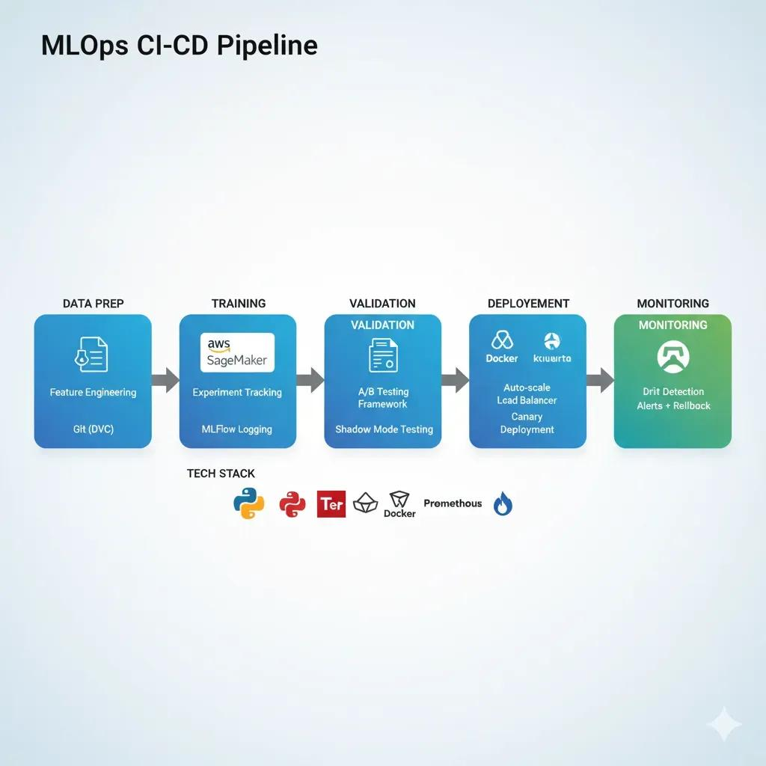
Module 9: AI Deployment and MLOps
- Git and GitHub
- Flask or FastAPI
- Deploying models using Streamlit
- Cloud fundamentals: AWS, Azure or Google Cloud
- Model monitoring and versioning
- Data pipelines and basic MLOps
- Responsible AI, privacy and model bias
Practical projects
A good course should include hands-on projects such as:
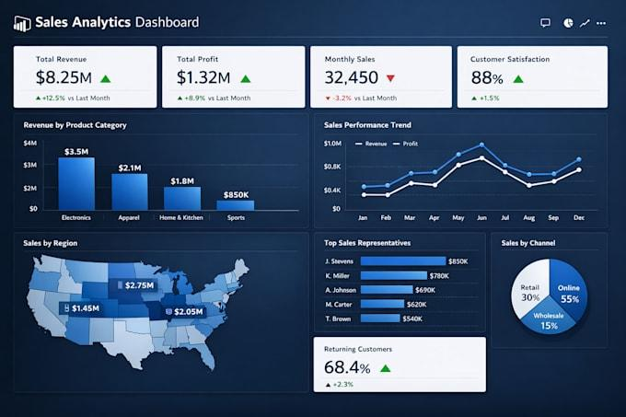
1. Sales Data Analysis
Use Python, Pandas, SQL and visualization tools to find sales trends and create dashboards.
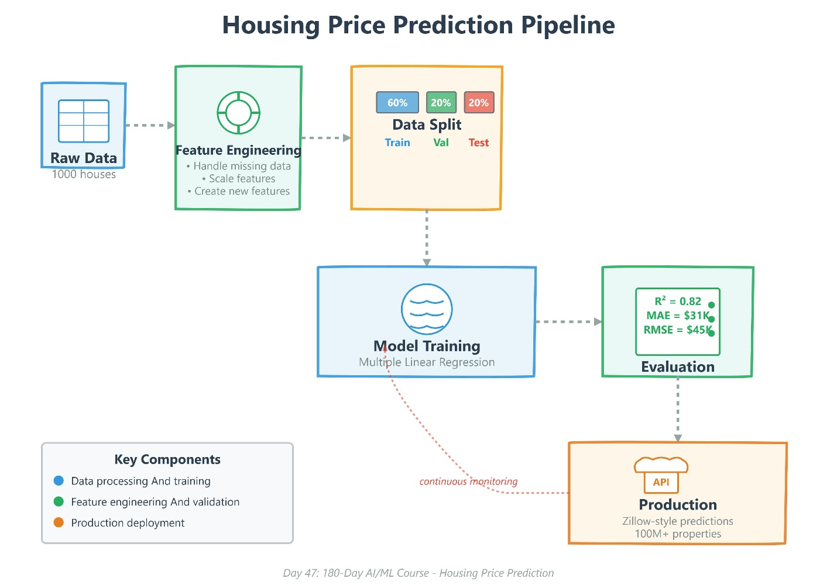
2. House Price Prediction
Build and evaluate a regression model using Scikit-learn.
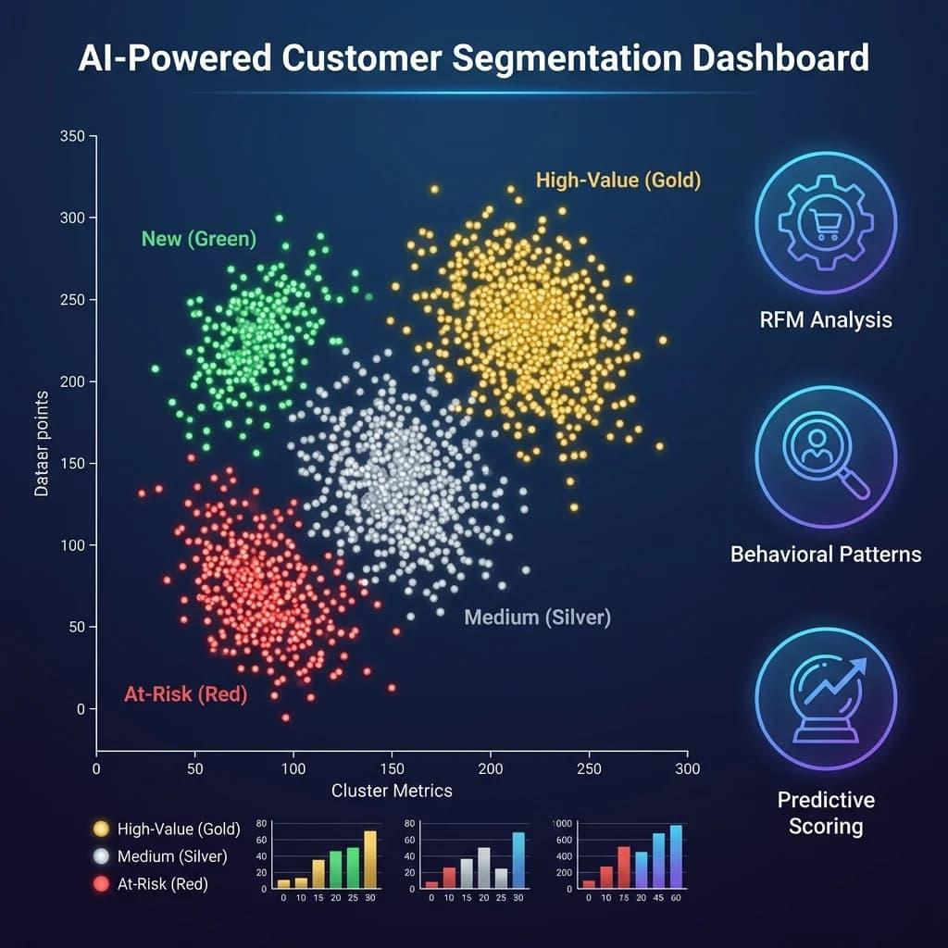
3. Customer Segmentation
Apply clustering algorithms to identify different customer groups.

4. AI Chatbot
Use an LLM API and prompt engineering to build a conversational assistant.
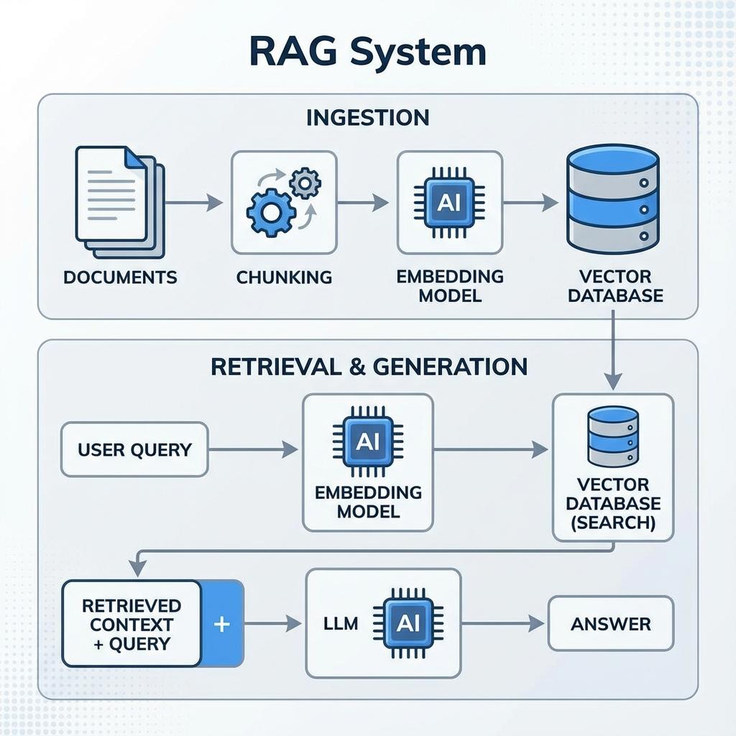
5. AI Document Question-Answering System
Create a RAG application that answers questions using uploaded documents.
Recommended course duration
Learning stage | Approximate duration
Python, SQL and statistics | 4–6 weeks
Data analysis and visualization | 3–4 weeks
Machine learning | 4–6 weeks
Deep learning and Generative AI | 4–6 weeks
Deployment and final projects | 2–4 weeks
Total | 4–6 months
The duration depends on your existing programming knowledge and weekly study time.
Career opportunities
- Data Analyst
- Junior Data Scientist
- Machine Learning Engineer
- AI Engineer
- Generative AI Developer
- Business Intelligence Analyst
- Data Science Intern
Let me tailor the syllabus to your needs
1. What is your current level?
Beginner — no programming knowledge
Basic Python knowledge
Experienced programmer or IT professional

